Kaizen App – Project Charter
Nov 2, 2026 · @BG

1. Project at a glance
This charter authorizes the build of Kaizen App, one web and mobile system that replaces the Excel-based Lean program at ProC, and names the Head of Lean (P.SXTG) as project owner. Release 1 goes live in all 9 units by 30/06/2027, the end of fiscal year 2026–2027; dates below are a proposal for the steering committee to confirm.
Item | Value
Project name | Kaizen App – Lean Management Transformation (digital Lean system)
Project type | Internal IT / digital transformation, method R&D (PMP), tracked in Kaizen App itself
Executive sponsor | Executive board (BTGĐ), Deputy General Director for Production (to confirm)
Project owner | Head of Lean department (P.SXTG)
Project manager | PMO (to appoint)
Delivery team | Development team (internal IT or vendor, to select)
Users | 9 units: TTCA, KSK, TTCS, ATN, NHS, PRS, GLS, TTNĐ, ProC office; 43 5S areas
Planned start | 03/11/2026 (charter approval)
Release 1 go-live | ATN pilot April 2027; all units by 30/06/2027
Phase 2 | Fiscal year 2027–2028 (CCTV AI, HR sync, advanced reports)
Reference documents | Product Requirements Specification (PRD/SRS), Process & Data Flows (BPMN 2.0), Data Model & API Design, clickable demo AgriS Kaizen_v06.html

2. Business case and objectives
The Lean program now runs on Excel files and paper 5S forms spread across 9 units, so the same figures are typed several times, CAPA follow-up depends on reminders, and leaders see results weeks late. The Compensation Scheme 2026–2027 V04 (effective 01/11/2026) pays rewards from these figures, which makes one trusted source of data a requirement, not a convenience.
Problems to solve
- 5S audits on paper (50 questions, QT-02/M02): scores and photos are retyped, and CAPA is raised by hand.
- Quick ideas and Kaizen projects are tracked in separate files; savings, approvals and tollgates are hard to audit.
- Reward amounts (T1–T6) are calculated manually against a 1.68 bn VND budget and a 9.4 bn VND hard-saving plan.
- Leaders receive reports late and in different formats; there is no early alert for NC major or safety hazards.
Objectives (targets to confirm by the steering committee)
- Digitize 100% of 5S audits in the 43 areas on phones by 30/06/2027, with CAPA created automatically from every finding of score ≤ 2.
- Record 100% of quick ideas, CI projects, approvals and tollgates in Kaizen App by 30/06/2027; stop the parallel Excel files.
- Calculate T1, T3 and T4 rewards in the system, matching the manual calculation for the pilot quarter with zero difference.
- Send leadership reports and 5S results by email automatically: audit results within 5 minutes of submission, monthly reports on the first working day.
- Put AI detection (YOLO) into the audit flow for 17 classes of 5S defects and safety hazards, with precision of at least 80% after human review.
Expected benefits: fewer hours spent compiling reports, faster CAPA closure, rewards that can be audited, and earlier warning on safety hazards. The value of these benefits is to be quantified by the project team in the Initiating phase and confirmed by Finance.

3. Scope and deliverables
Release 1 covers the full Lean cycle from capture (audit, idea, project) to approval, reward and report; anything that writes back to ERP or payroll stays out.
In scope (release 1) | Phase 2 | Out of scope
Master data, users, roles, unit data scope | HR sync, org chart import | Write-back to ERP or Microsoft Dynamics 365
5S audit on phone (offline), scoring, report, CAPA with before/after photos | Audit planning calendar, offline conflict screen | Payroll payment itself (HR receives a file)
Quick ideas levels 1–3, approval, transfer to Kaizen | Idea-to-project data carry-over | Face recognition, disciplinary use of AI
CI projects PDCA, DMAIC, R&D with approvals, tollgates, monthly data, EVM, NPV | Risk register screen, change requests | Hardware purchase beyond pilot devices
Rewards T1, T3, T4 and ledger | T2, T5, T6 automation
Reports: BOD, project progress & quality, 5S | Reward program report, Excel/PDF export
Email to leadership: audit result, high-severity alert, monthly BOD and plant emails | Weekly CAPA, quarterly ranking, PDF attachment
AI detection on the phone (ONNX), review, CAPA from detections | CCTV server inference, model registry, retraining loop
Deliverables
# | Deliverable | Owner | Accepted by
D1 | Approved requirements: PRD/SRS, BPMN 2.0 flows, data model & API (drafts exist) | Project owner | Steering committee
D2 | Solution architecture and tech stack decision | Development lead | IT, project owner
D3 | Working release 1 (web + PWA) with database schema, API and OpenAPI file | Development team | Project owner after UAT
D4 | AI model v1 (YOLO, 17 classes) trained on ProC photos, ONNX file and evaluation report | Data science (LEAN + vendor) | Project owner, EHS
D5 | Test evidence: acceptance criteria AC-01 to AC-18 and AC-E1 to AC-E7 passed | Development team, LEAN testers | Project owner
D6 | Data migration of master data, open CAPA, running projects and the 2026–2027 reward ledger | LEAN, development team | Finance (reward data), LEAN
D7 | Training: user guide, OPL per role, train-the-trainer for each unit's CI coordinator | LEAN | Unit plant directors
D8 | Security review, penetration test and data protection impact assessment | IT, Legal | IT security, Legal
D9 | Hand-over to operations: runbook, support model, backup and restore test | Development team, IT | IT

4. Milestones
The project follows the R&D phases already used in Kaizen App (Initiating, Planning, Executing, Monitoring, Closing); the AI dataset runs in parallel from November so the model is ready for the pilot.
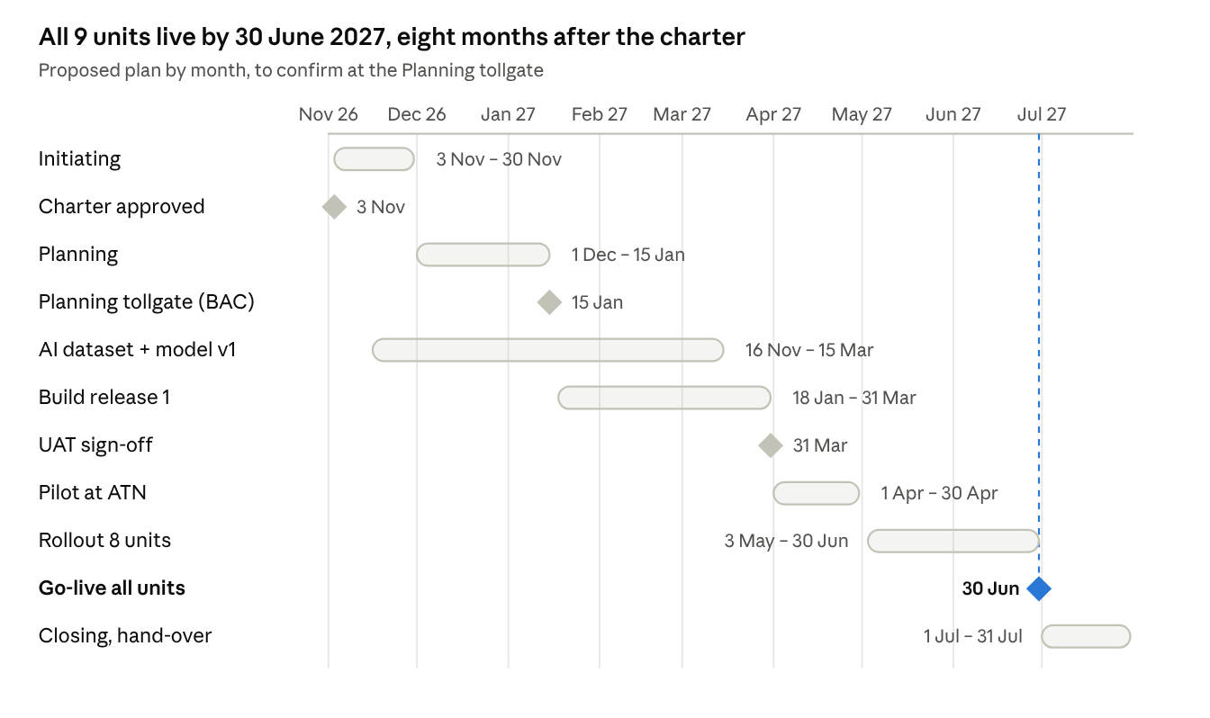
milestones · proposed plan Nov 2026 – Jul 2027
Gate criteria: the Planning tollgate needs the architecture, backlog, budget (BAC) and answers to the PRD open questions; UAT sign-off needs all acceptance tests passed on pilot data; go-live in each unit needs master data migrated, trained users and a reconciled reward ledger.

5. Governance and roles
The steering committee meets monthly and decides scope changes, budget and go-live; the project owner decides requirements and priorities within the approved scope; the project manager runs the plan day to day.
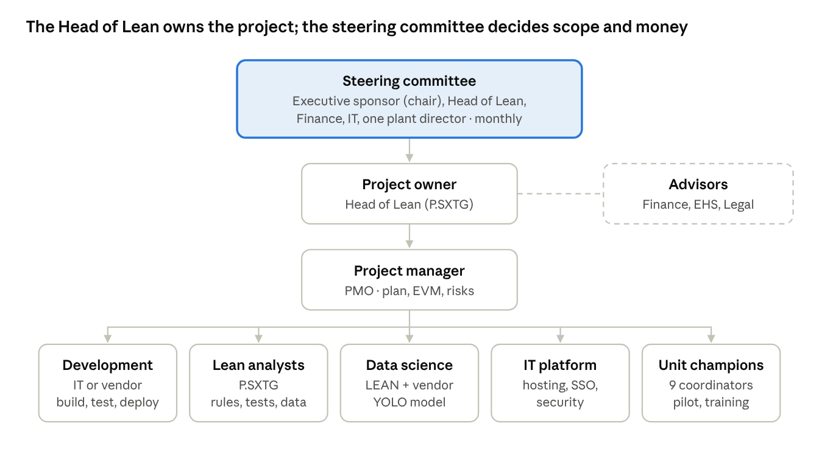
project governance · steering committee, owner, PM, 5 workstreams
RACI (R = responsible, A = accountable, C = consulted, I = informed)
Activity | Steering committee | Project owner | Project manager | Development | Lean analysts | Finance | IT | Unit champions
Approve charter, budget, go-live | A | R | C | I | I | C | C | I
Requirements and priorities | I | A | C | C | R | C | C | C
Plan, schedule, EVM, status report | I | A | R | C | C | I | C | I
Architecture and tech stack | I | A | C | R | I | I | C | I
Build and test | I | A | C | R | R | I | C | C
Reward rules and reconciliation | I | A | I | C | R | R | I | I
AI dataset and model | I | A | C | C | R | I | I | C
Security and data protection | I | A | C | R | I | I | R | I
Pilot and rollout | C | A | R | C | R | I | C | R
Training and adoption | I | A | C | I | R | I | I | R
Escalation: issues the project manager cannot resolve in 5 working days go to the project owner; scope, budget or go-live date changes go to the steering committee.

6. Budget and resources
No budget has been estimated yet; the project team prepares the estimate in the Initiating phase and it becomes the BAC baseline at the Planning tollgate. As an R&D project, it follows the app's own approval chain: plant director → LEAN → Finance → Executive board.
Cost category | Includes | Estimate (VND)
Development | Build of release 1 (internal team or vendor contract) | To estimate
Infrastructure | Hosting, PostgreSQL, object storage, backup, GPU server for phase 2 | To estimate
Licences and services | Microsoft 365 service mailbox and Graph API, LLM API for 5 Why drafts, labeling tool | To estimate
AI model | Photo collection, labeling (≥ 300 images per class), training | To estimate
Devices | Phones or tablets for auditors where personal phones are not allowed | To estimate
Security | Penetration test, data protection impact assessment | To estimate
Internal effort | LEAN, IT, Finance, unit CI coordinators; costed at 312 h per FTE-month | To estimate
Contingency | Share of the total, to set by Finance | To estimate
People (time commitment to confirm at kick-off)
Role | From | Main contribution
Project owner | Head of Lean (P.SXTG) | Requirements, priorities, acceptance
Project manager | PMO | Plan, EVM, risks, status reports
Lean business analysts | P.SXTG | Rules, test cases, data migration, training
Development team | IT or vendor | Design, build, test, deploy
Data science | LEAN with vendor | YOLO dataset, training, evaluation
Finance reviewer | P.TCKT | Savings, reward formulas, budget
IT security and infrastructure | IT | Hosting, SSO, security review
EHS reviewer | EHS | Safety classes and alerts
Unit champions | CI coordinator of each unit | Pilot, user feedback, local training

7. Success criteria and KPIs
The project is accepted when release 1 passes all acceptance tests and the adoption targets below hold for the first full month after rollout (July 2027).
KPI | Target | Measured from | When
5S audits done in the app | 100% of planned audits in 43 areas | audit vs audit_plan | Monthly from July 2027
CAPA created automatically from findings | 100% of scores ≤ 2 | audit_answer vs capa | From pilot
Overdue CAPA | Lower than the June 2027 baseline (target to set at pilot) | capa status Overdue | Monthly
Quick ideas recorded in the app | 100%, no parallel Excel | quick_idea | From rollout
Projects with monthly data on time | ≥ 90% | project_month | Monthly
Reward calculation | 0 difference vs manual check for the pilot quarter | reward_line | End of pilot
AI precision after review | ≥ 80% | ai_detection.review | From model v1
Audit result email | Sent within 5 minutes of submit | email_message.sent_at | From pilot
Acceptance tests | AC-01 to AC-18, AC-E1 to AC-E7 passed | Test report | Before go-live
Schedule and cost | SPI and CPI ≥ 0.95 | Project EVM | Monthly
User satisfaction | ≥ 4 of 5 in the post-rollout survey | Survey of auditors and area owners | August 2027

8. Assumptions, constraints and dependencies
Assumptions
- The 5S handbook, QT-02/M02 audit form and Compensation Scheme 2026–2027 V04 stay stable during the build; changes go through change control.
- Auditors and area owners can use a smartphone on the shop floor (company or personal device, per IT policy).
- Each unit names a CI coordinator who gives about one day per week during pilot and rollout.
- Enough photos can be collected from audits and CAPA to train the AI model (≥ 300 per class, ≥ 500 for safety classes).
Constraints
- Go-live in all units by 30/06/2027 so fiscal year 2027–2028 rewards run in the system.
- Personal data must comply with Law 91/2025/QH15 and Decree 356/2025/NĐ-CP; no face recognition, no disciplinary use of AI results.
- Kaizen App is standalone: no write-back to ERP or Microsoft Dynamics 365.
- Sugar crushing season (main harvest months) limits shop-floor time for pilots and training in some units.
Dependencies
Dependency | Needed for | Owner | Needed by
Hosting decision (company data center or cloud tenant) | Architecture, security review | IT | Planning tollgate
Microsoft Entra ID app registration and service mailbox | Login, email to leadership | IT | Start of build
Role-to-mailbox list per unit and area | Email routing | LEAN, HR | Before pilot
Decisions on PRD open questions (AT codes, CI Star threshold, T5 data, retention) | Final rules | LEAN, Finance, EHS, Legal | Planning tollgate
Master data clean-up (areas, zones, owners) | Migration | LEAN, unit coordinators | Before pilot

9. Key risks and responses
# | Risk | Likelihood | Impact | Response | Owner
R1 | Units keep using Excel in parallel, so data stays split | Medium | High | Stop Excel templates at go-live of each unit; rewards paid only from app data | Project owner
R2 | Reward calculation differs from the manual one and loses trust | Medium | High | Parallel run for the pilot quarter; Finance signs off the reconciliation | Finance
R3 | Too few labeled photos; AI precision below 80% | High | Medium | Start photo collection now from audits and CAPA; keep AI as suggestion only; release AI per class when it meets target | Data science
R4 | Weak mobile signal on the shop floor | Medium | Medium | Offline audit and sync (FR-37); test in each unit during pilot | Development lead
R5 | Personal data or photo privacy complaint | Low | High | Face blur on device, data protection impact assessment, Legal review before go-live | IT, Legal
R6 | Scope grows (new modules, ERP links) and delays go-live | Medium | High | Change control through the steering committee; phase 2 list kept separate | Project manager
R7 | Development partner or team not available in time | Medium | High | Decide build option by end of Initiating; keep the demo and docs as the contract baseline | Project owner
R8 | Crushing season leaves no time for pilot and training | Medium | Medium | Pilot in ATN with a fixed window; train-the-trainer before the season | Unit plant directors

10. Approval
Signing this charter authorizes the project owner to start the Initiating phase, appoint the project manager and use internal resources named in section 6; the budget itself is approved at the Planning tollgate.
Role | Name | Signature | Date
Executive sponsor (Executive board)
Project owner (Head of Lean, P.SXTG)
Finance (P.TCKT)
IT
Project manager (PMO)

